Minda

- Parts of a Bee
Students: Viktor, Theo, Henrik
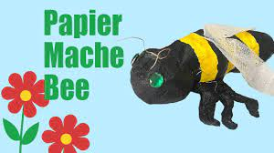

- Create a 3D paper mache of a bee
- Label each part

Link: Making a Bee with Paper Mache
https://www.youtube.com/watch?v=qJiN6QkBZvM

- Parts of a Hive – natural & wooden
Students: Gia, Jayna, Quinn

- 3D hive with wooden bees on the outside, painted yellow etc.
- Information about each part of the hive (poster board)
- Model of a hive and activity: Guess how many bees there are? (with prizes)
- How is honey made? There can be different kinds of honey.
- Represent the project in a wooden bee hive
- What is a hexagon? And why do the bees use that shape in their honeycomb?

Links :
How to make a paper hive.
https://www.youtube.com/watch?v=U8trZW1Rtuc
Parts of a wooden bee hive.
https://www.youtube.com/watch?v=y7O0KSp-4b4
Natural hive
https://www.wholekidsfoundation.org/inside-the-beehive

What shape is a beehive structure?
Hexagons are useful shapes. They can hold the queen bee's eggs and store the pollen and honey the worker bees bring to the hive. When you think about it, making circles wouldn't work too well. It would leave gaps in the honeycomb.
https://www.nwpb.org/ask-dr-universe/why-do-bees-make-hexagons-in-their-hives/#:~:text=Hexagons%20are%20useful%20shapes.,leave%20gaps%20in%20the%20honeycomb.
“The geometry of this shape uses the least amount of material to hold the most weight,” she said.
It takes the bees quite a bit of work to make the honeycomb. The wax comes from glands on the bees’ bellies, or abdomens. Honeybees have to make and eat about two tablespoons of honey to make one ounce of wax. Then they can add this wax to the comb as they build. A bee colony can produce 100 pounds of honey, Cobey said. In some places they can even produce 300 to 500 lbs. The structure is important to hold all this weight and protect the honey, especially during winter.
The hexagon might just save bees some time and energy. They can use the energy to do another really important job: carry pollen from flower to flower that allows new plants to grow. It’s my cat instinct to swat at a bee, but I try not to because bees are really important. They make it possible for us to eat food.
Having a sturdy and useful hive can help bees get the job done.
Not too long ago, some scientists wondered how exactly the bees build these hexagons. They found certain bees would start out making circles in the wax using their body as a tool. Scientists don’t really know why it happens, but the bees seem to be using their body heat to melt the wax from a circle shape into a hexagon shape.
Hexagons and honeycomb shapes are also useful for building things humans use, too, like bridges, airplanes, and cars. It gives materials extra strength.
After all, materials made with hexagon shapes can also handle a lot of force, even if they are made out of a lighter material. That’s what I learned from my friend Pizhong Qioa, an engineer and professor at WSU.
“We learned it from the bee,” he said. “Hexagons apply to almost everything you can build.”
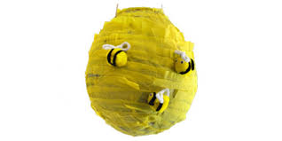

Beehive facts for kids
Kids Encyclopedia Facts

Wooden beehives in Minnesota in the United States
A beehive is a structure in which some species of honey bees (genus Apis) live and raise their young. Natural beehives (or "nests") are made by honey bee colonies, while domesticated honey bees are kept in man-made beehives in a location known as an apiary. The beehives made by people are usually the things referred to by the word "beehive."
Beehives have hexagonal cells in them, packed together. This is called a honeycomb.

Honey bees use caves, rock cavities and hollow trees as natural nesting sites.
Humans often destroy hives of honey-producing bee species in the interest of obtaining honey and other bee products.
Humans may at times also determine that a beehive must be destroyed in the interest of public safety or in the interest of preventing the spread of bee diseases.
Black bears destroy hives in their quest for honey.

- Life Cycle of a Honey Bee
Students: Johan, Dayan

- 3D representation of a the life cycle (plasticine)
- Also posterboard with the stages in a circle and real pictures. A little information about each stage of development.
- Explanation for each part
How long it takes?
What each stage is called?
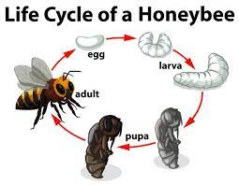
Life Cycle of a Honeybee (for kids)
https://www.youtube.com/watch?v=xD5tdykIJBI
The Life cycle of a honeybee for kids
https://www.youtube.com/watch?v=LM7eEitKcIM

- Different Kinds of Bees in BC (Species)
Students: Isabel, Naomi

- How many different kinds are there in BC
- Different kinds and images in each honeycomb (they can choose how many)
- Why do Bees sting? Do all bees sting?
- What to do so you don’t get stung?
- What is the difference between a bee and a wasp?
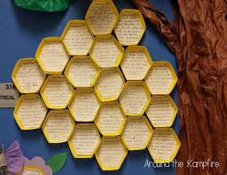

15 Types of Bees found in British Columbia
https://birdwatchinghq.com/bees-in-british-columbia/
Bee Monitoring Guide
https://www.kamloops.ca/sites/default/files/docs/our-community/tsmg_bee_identification_guide_ff3.pdf
Ways to prevent getting stung by a Bee
https://health.clevelandclinic.org/simple-steps-to-prevent-and-treat-bee-and-wasp-stings/
Why do bees sting and how to prevent getting stung?
https://www.childrensmuseum.org/blog/why-do-bees-sting#:~:text=Bees%20sting%20either%20because%20they,defense%20to%20get%20you%20away.

- Different Kinds of Bees and Roles
– Queen, Drone, Worker Bee

Students: Peter, Isaac, Carter

- Descriptions: The differences between them physically and their roles
- Diagrams/images of each
- Poster Board
- Props
- Secondary roles: undertaker etc.

Whole Kids Foundation
https://www.wholekidsfoundation.org/inside-the-beehive

Queen Bee Worker Bee Drone
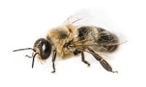
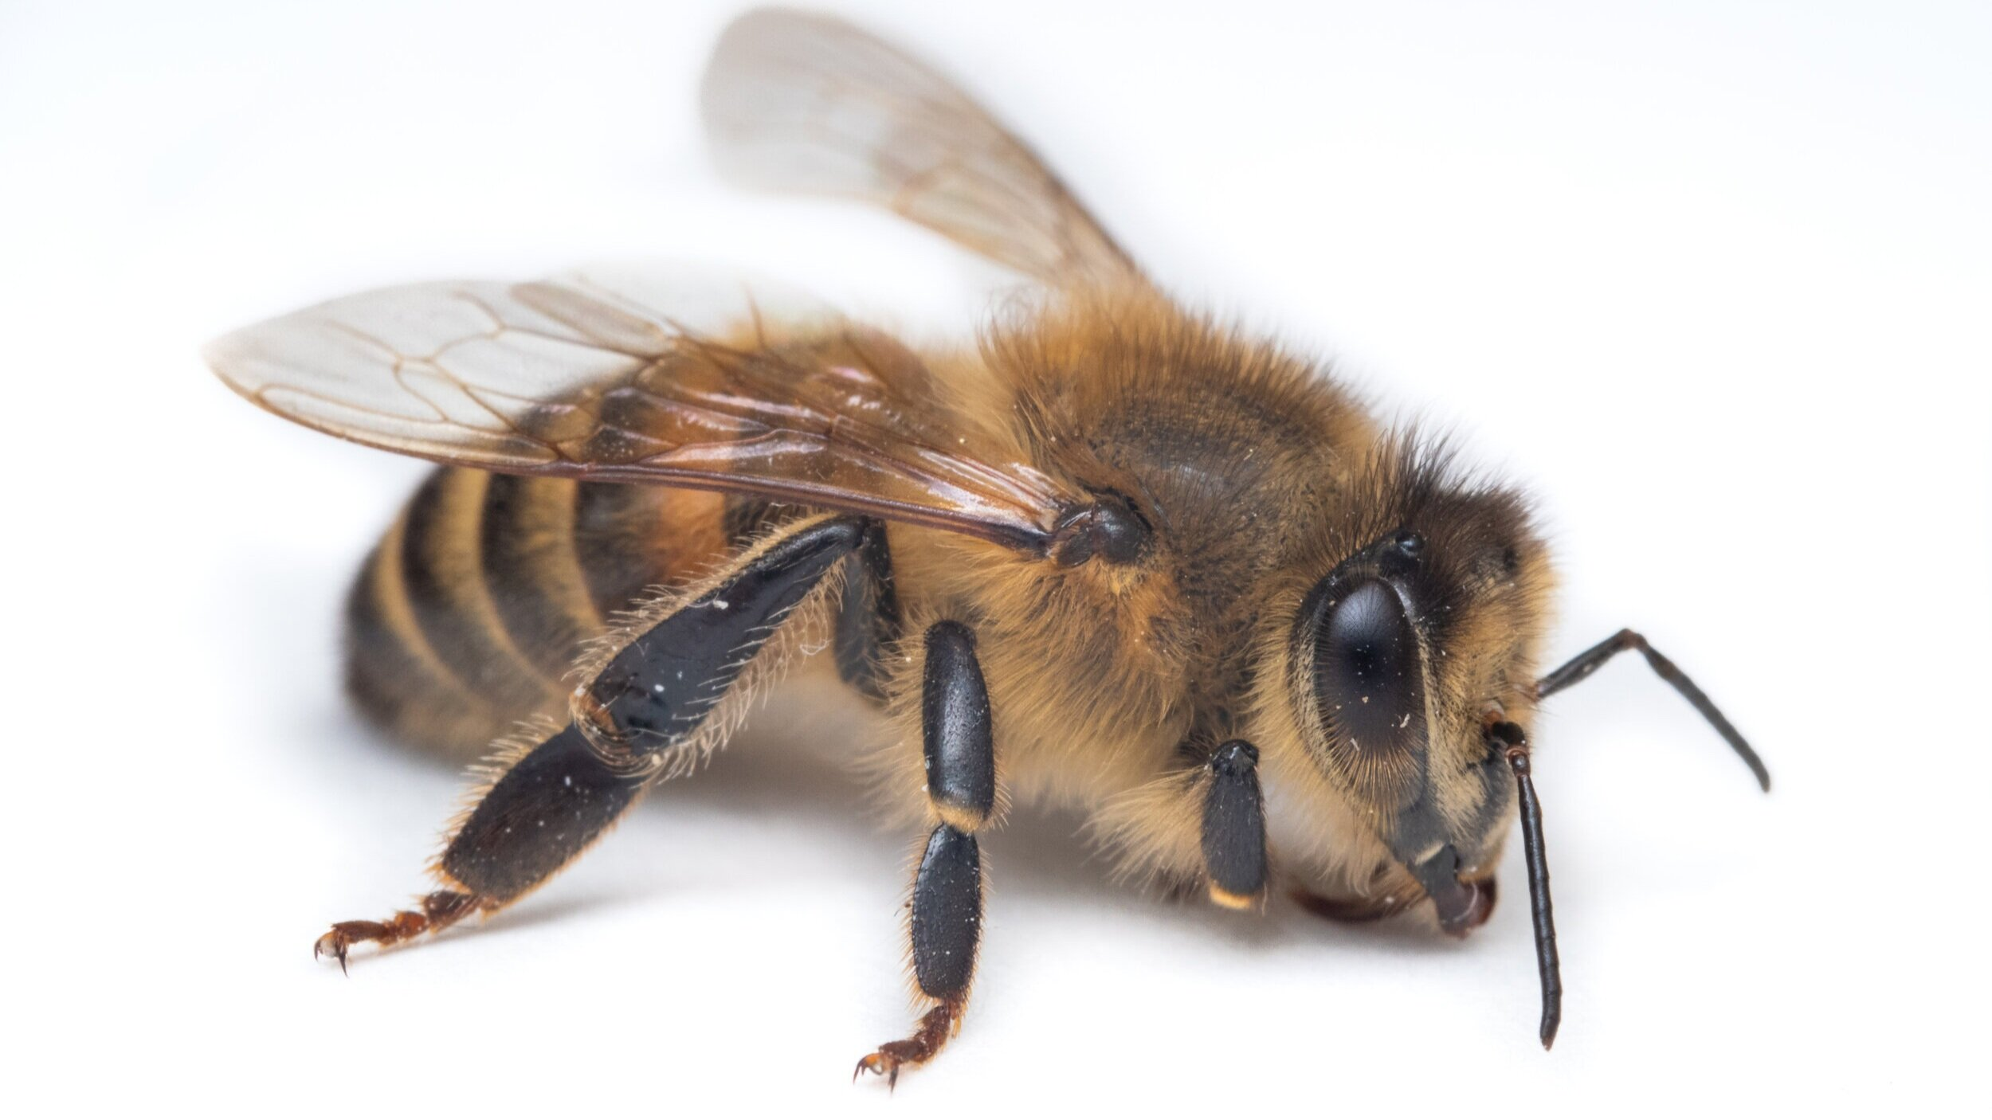
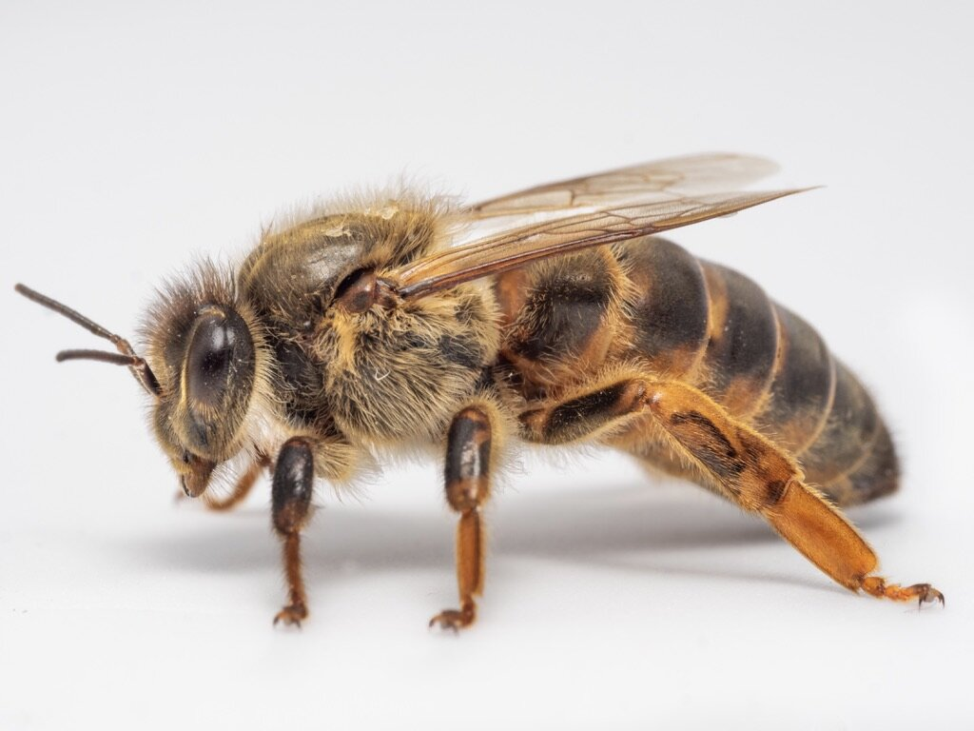

- Interesting Facts about Bees

Students: Isaiah, Rylan, Nathaniel

- Computer work
- WS – Facts about bees
- Use books
- Facts and images
- Representation: Globe, Computer, honeycomb
What happens when the queen dies?
Talk about the dances of bees
How many bees are in a colony?
https://www.natgeokids.com/au/discover/animals/insects/honey-bees/
Bee facts
https://www.coolkidfacts.com/bee-facts/
https://www.canadaaction.ca/canadian-honeybees-facts

- What do bees actually do? Pollination and honey-making explained.

Students: Scarlett, Ruby

- Stem activity
- Poster board explaining pollination
- Also, explaining how they make honey
- Cheetos pollination

Link: Pollination activity
https://www.preschoolplayandlearn.com/simple-jello-bee-pollen-experiment-for-kids/
WS—Pollination explained
WS—Bee pollinators

Bee Honey Making Process: Step-by-Step
When the weather gets warmer and flowers start to bloom, honeybees will leave their hives in search of flowers. The actual process for making honey goes like this:
- Once they find a flower, they will use their long tongue like a straw to suck nectar, a sugary juice, out of the plant.
- The nectar is stored in a second stomach, also known as the “honey stomach.”
- After they have filled up their second stomach, the bees will return to their hive and start to pass the nectar through their mouths to other bees.
- These bees will chew on the nectar for about 30 minutes.
- Then they pass it along to another bee!
- As the nectar is passed from bee to bee, it is turned into honey.
- Once the nectar becomes honey, the honeybees will store it in honeycomb cells, which act as little jars made of wax.
- The bees then flap their wings over the honey to make it thicker and more like syrup instead of sweet juice.
- Once the honey is ready, the bees will seal the cell using a wax lid to store it for later.
- At this point, skilled beekeepers can take some of the finished honey from the hive, taking care to not harm or damage the colony.
Honeybees create delicious honey and help pollinate flowers to keep them alive. And while it’s interesting to see how bees make honey, they can also sting if they feel threatened. If you see a honeybee or hive, it is important to observe it from a safe distance and with help from a grown-up, like a parent or teacher.

- What would the world be like without bees? Other ways that bees help people? Indigenous content.

Students: Lux, Solaya

- Game
- Information here is not sourced.
- Honey, of course, is the most well-known and economically important hive product.
- The market remains strong today. Beeswax is popular for making candles and as an ingredient in artists’ materials and in leather and wood polishes. The pharmaceutical industry uses the substance as a binding agent, time-release mechanism, and drug carrier. Beeswax is also one of the most commonly used waxes in cosmetics.
- Honeybee products have a long medicinal history. All cultures have folk medicine traditions that include the use of honeybee products, that is, honey, bee pollen, propolis, royal jelly, beeswax, and bee venom. These products have been found to exhibit anti-inflammatory, anti-bacterial, anti-fungal, anti-viral and antioxidant activities. It has been also shown that natural honeybee products inhibit tumor cell growth and metastasis and induce apoptosis of cancer cells. Hence, these bioactive natural products may prove to be useful in cancer therapy.
- What is the healing benefits of bees?
- Bee pollen contains many vitamins, minerals and antioxidants, making it incredibly healthy. Studies have linked bee pollen and its compounds to health benefits such as decreased inflammation, as well as improved immunity, menopausal symptoms and wound healing.

FIRST NATIONS:
The Bee
The Native Bee Symbol symbolizes honesty and willingness to serve the community above all. In Northwest Coast Cultures, Masked Bee Dancers are often intended to be amusing during dances. The dancer with the Bee Mask would dance around and touch other dancers and people with their sharp barbs or stingers. The individuals stung by the bees during their dance would often be compensated for the stings, by receiving special small gifts given during the potlatches.
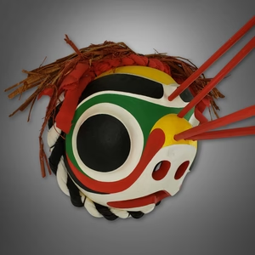
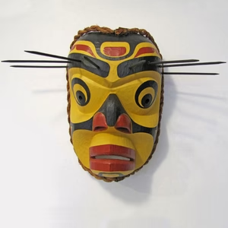
Bee Masks

The Native Bee Symbol symbolizes honesty and willingness to serve the community above all. In Northwest Coast Cultures, Masked Bee Dancers are often intended to be amusing during dances. The dancer with the Bee Mask would dance around and touch other dancers and people with their sharp barbs or stingers.

Many Indigenous communities historically used honey as medicine [13, 14], which may have a positive effect on its uptake and usage by clinicians and patients, as has been the case with other traditional medicines [15]. https://www.uts.edu.au/sites/default/files/sci-loraine-holley-essay-2016-daniel-bouzo.pdf

- What is the problem facing Bees?
What can YOU do to help save the Bees! Here is what WE did!
- Ideas/Examples of things you can do
- What kinds of plants can you plant that bees like?
- Bee bath
- Bee hotel
- Don’t kill them
- Don’t use pesticides
- Tell other
- Picture board of what we did

