REFLECTION on BEE Theme
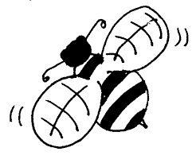
Name ___________________

Circle the number that shows your feeling:
1 – terrible 2 – not so great 3 – so, so 4 – very good 5 – excellent

- How did you enjoy the field trip to the Honey Bee Centre?

1 2 3 4 5

- What did you learn on that trip?

_______________________________________________________________________________

- How did you enjoy the field trip to the Blueberry Farm?

1 2 3 4 5

- Is there anything you think we could have done better?

_______________________________________________________________________________

- How did you enjoy our BEE Day?

1 2 3 4 5

- Name 2 things that went really well on BEE Day:

_______________________________________________________________________________

_______________________________________________________________________________

- Name 1 thing that we could have done better on BEE Day:

_______________________________________________________________________________

- Would you recommend that next year’s Grade 2 students study and help the bees?

- Do you think you helped the BEES? (circle one)

Yes / no

“We can’t do everything,
But we CAN do something!”

