**Ways to help the BEES in BC:**

Plant flowers that bees like.

Don’t use pesticides.

Set up a bee house or a bee bath.

Don’t destroy bee hives.

Spread the message!

*We can’t do everything – but* ***WE CAN*** *do something!*

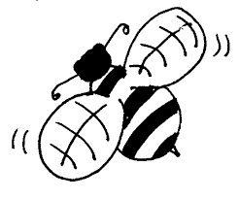

**Ways to help the BEES in BC:**

Plant flowers that bees like.

Don’t use pesticides.

Set up a bee house or a bee bath.

Don’t destroy bee hives.

Spread the message!

*We can’t do everything – but* ***WE CAN*** *do something!*

**Ways to help the BEES in BC:**

Plant flowers that bees like.

Don’t use pesticides.

Set up a bee house or a bee bath.

Don’t destroy bee hives.

Spread the message!

*We can’t do everything – but* ***WE CAN*** *do something!*

**Ways to help the BEES in BC:**

Plant flowers that bees like.

Don’t use pesticides.

Set up a bee house or a bee bath.

Don’t destroy bee hives.

Spread the message!

*We can’t do everything – but* ***WE CAN*** *do something!*







**Save the BEES!**

**Save the BEES!**

**Save the BEES!**

**Save the BEES!**