Honouring Stories Project
You will choose a person from a marginalized community to research and honour their story by writing a “Where I’m From” poem about this person’s life story. You will also create a portrait in Art to represent them visually. Your poem and Art will be put on display for people to walk through and look at.
Step 1: Research
Spend some time researching about your person. Look through videos, websites, books, etc. to get a good understanding of who your person is/was, how they or their group was marginalized, and what is important about their story.
- Biographical information – Who are they? Where were they born? Describe family life, home life, school life. What is significant about their life? What career did they have?
- How were they/their group marginalized? – Find information from your research, think back to history lessons about their group.
- What is important about their story? – What struggles have they faced? How did they contribute to their country? What is significant about their story?
- What now? – What can you do? Write a prayer for this person/group.

Step 2: Write “Where I’m From” poem
Use your research to write a “Where I’m From” poem about your person’s life story. Be sure to include their biographical information, how they/their group has been marginalized, and what is important about their story.
Example:
Martin Luther King Jr.
He is from segregation, civil rights, and taking a stand
From drinking from “coloured” fountains, separate but equal
He’s from fighting for the rights of his community
From empowering others to make a difference
He is from “I Have a Dream,” a speech that inspired a nation
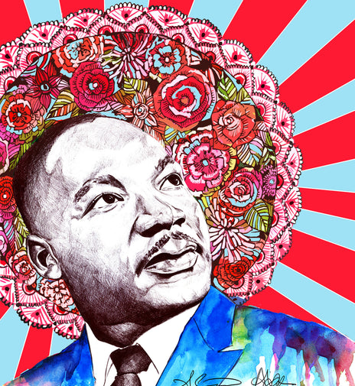
Step 3: Create a portrait
Create a portrait on canvas that honours the person and their story.
- Create a black and white portrait on paper.
- Paint the background of your canvas.
- Mod podge your portrait on top of your canvas.

