Before and After
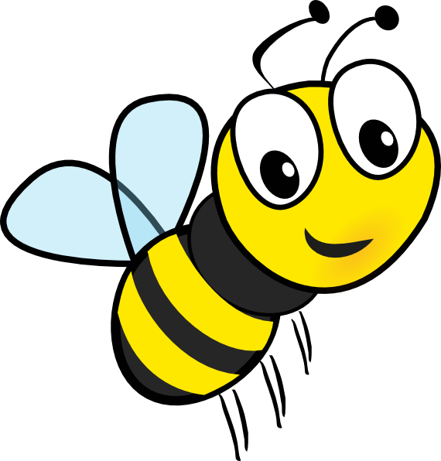
Name ______________________________________
Field Trip to ‘Save the Bees’
Draw what the field looked like before and after.
Before

After

